Donate used printer cartridges to help Martin County children in need
Childrens_Emergency_Resources 12:00 PM, Jan 11, 2012
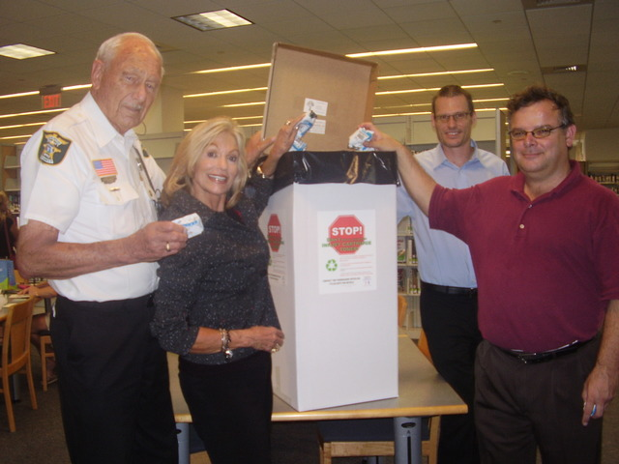
STUART - The Martin County nonprofit 501c3 Children's Emergency Resources (CER) has begun a new program in cooperation with The Martin County Library System. The idea was developed by Dale Hoffa, Chairman of the CER Board.
For the past few years, local businesses and offices have been donating used cartridges to CER; those cartridges are then turned over for recycling and refurbishing by manufacturers, who in turn reimburse CER for its efforts.
Recently Hoffa teamed up with Martin County Library System's Associate Director for Public Services, Judi Snyder, and Library Director Brett Lear to implement the program. Chris Schmidt of the Stuart firm Photographics, designed and contributed the donation boxes which can now be found in the main library and branches.
Snyder said that it's a convenient and easy way for library patrons to help this good cause. "Just drop the cartridges in the prominently located boxes instead of discarding them, and you can help local children in need. The Martin County Library System is pleased to help with this program."
Hoffa explained that CER is dedicated to serving Martin County children in need of medical care. "Since 1979, Children's Emergency Resources (CER), has been providing medical exams and assessments, prescription medications, dental services, optical exams and glasses, special requests and crisis intervention to low socio-economic status children and youth in Martin County."
CER provides assistance to children of Martin County only (Stuart, Jensen Beach, Port Salerno, Indiantown, Hobe Sound and Palm City). Through the networking initiative with every health assistant in every school in Martin County, Children's Emergency Resources keeps up to date on community needs.
This agency, funded in part by United Way, has been on the forefront of interagency collaborations to offset, defray and supplant expenses when needed and to assist other agencies in need of support.
CER Board President Dr. Sandra McNeal urges all Martin County residents to help support the work of CER. McNeal added, "We hope that all residents will help with our used cartridge program. CER has no offices and only small professional fees are paid from time to time. All of our board members are volunteers. Almost every dollar goes to the children in need of medicine, glasses, dental work, etc."

